Feedback Survay Module

For Magento2

The Survey Form serves as a specialized tool within the Magento2 platform, facilitating customer feedback and data collection. Its purpose is to offer website visitors a streamlined method for expressing their experiences and providing suggestions. Operating in a straightforward manner, this tool is ideal for customers seeking to gather personal information from website visitors and empower them to share their thoughts and ideas

**Admin Setting**

Main menu >> Ad Feedback Survey >> Survey Listing  
  
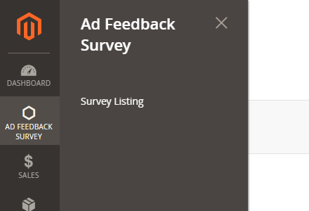

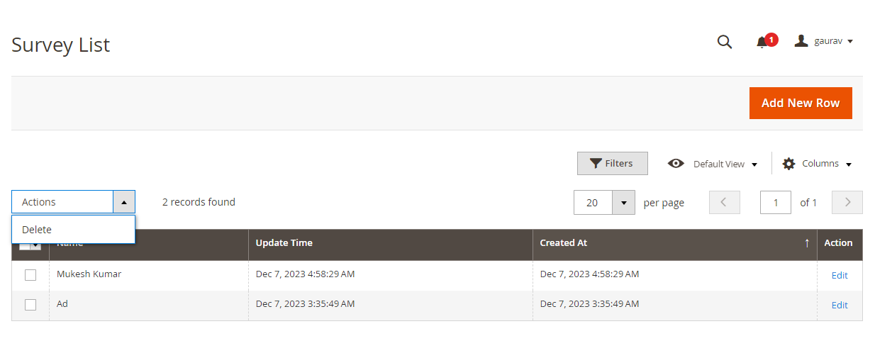  
  
  
**Front URL and Form  
  
Front URL:** /feedback-customer-survey